Age & Opportunity Tyrone Guthrie Centre Residency Award 2026
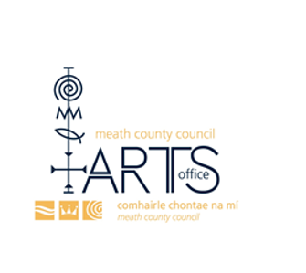
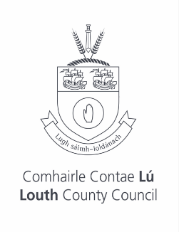
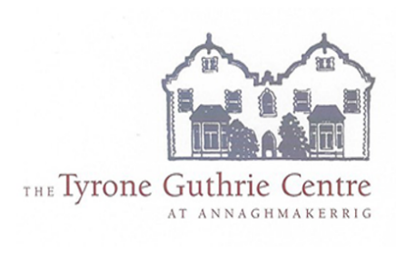
  - Deadline 12pm (noon), 10th June 2026

Information for applicants
Age & Opportunity is the national organisation that provides a range of opportunities for 50+ people who want to get more involved in arts and culture, sport and physical activity, civic engagement and personal development.

Specifically, our Arts programme aims to support and provide resources for artists, arts participants/audiences and arts organisations. We do this through our annual Bealtaine Festival, which is Ireland’s month-long (May) national festival celebrating the arts and creativity as we age and our Resource and Development Programme.

Residency Award
The Age & Opportunity Tyrone Guthrie Centre Residency Award (in partnership with Meath and Louth County Councils) aims to support professional artists of 50+ to develop their practice, by creating time and space to think and reflect on their work and to bolster their peer network. This will be achieved through a dedicated bursary to attend a residency over the course of a week.

This award is a partnership between Meath County Council Arts Office, Louth County Council Arts Office and Age & Opportunity and is in association with the Tyrone Guthrie Centre.

Two artists (one based in Meath and one based in Louth) will receive a funded week-long residency in the Tyrone Guthrie Centre including a small stipend.

The residency must take place between July and December 2026.

Call for Applications
Application Process:
Those wishing to apply for the Age & Opportunity Tyrone Guthrie Centre Residency Award should complete the application form, as well as sending a short biography, CV and three samples of work.

Eligibility criteria

Applicants must be:
- A professional artist (working in any artform) aged 50 +;
- Recognised as a professional artist by their peers – for example, membership of an associated professional organisation;
- Working in any artform but must be based in Meath or Louth.

Selection criteria
- A proven track record in their field of endeavour, for example:

  - Authors across all genres including playwrights must have a piece of work published;
  - Visual artists must have had one solo exhibition in a recognised professional venue and/or work selected for a group exhibition by a professional curator, and/or work in a recognised public collection;
  - Musicians / composers / theatre makers etc. must have proven professional experience.
- Demonstration of ambition and vision for their work with dedication to their artistic development;
- Demonstration of how this award will benefit the development of their creative practice;
- Understanding of Tyrone Guthrie Centre and its ethos;
- Quality of supporting material.

Applications should be submitted to artsfunding@meathcoco.ie if applying from Meath and arts@louthcoco.ie if applying from Louth, no later than 12pm (noon), 10th June 2026.

Any queries relating to the award may also be directed to artsfunding@meathcoco.ie if applying from Meath and arts@louthcoco.ie if applying from Louth.

Equality, Human Rights, and Diversity
Please note that Age & Opportunity welcomes applications from all communities, and particularly encourages artists from underrepresented communities to apply.
In line with the Public Sector Equality and Human Rights Duty, and in line with our core funders, Age & Opportunity is committed to ensuring that it takes positive policy measures and commitments to promote equality of opportunity for all those living in Ireland, regardless of their gender, sexual orientation, civil or family status, religion, age, disability, race or membership of the Traveller Community. Furthermore, Age & Opportunity notes the ground of socioeconomic background as a further basis for which equality of opportunity must be guaranteed.
As such, Age & Opportunity is committed to increasing the diversity and inclusion of our work.

More Information
Age & Opportunity
Age & Opportunity is the national organisation that provides a range of opportunities for older people who want to get more involved in arts and culture, sport and physical activity, civic engagement and personal development.

Our vision is an Ireland where all older people can be more active, more visible, more creative, more connected, more confident, more often.

We work with local communities and organisations across the country to run a range of programmes and activities in three key areas:

- Age & Opportunity Arts provides opportunities for us to engage more in arts and cultural events and initiatives
- Age & Opportunity Active is designed to get us more active and participate in recreational sport and physical activity
- Age & Opportunity Engage offers a range of workshops and learning initiatives for our own personal development as well as opportunities for us to play an active role in our community.

Age & Opportunity Arts is our dedicated arts and culture programme running throughout the year in local communities all over Ireland. We host a range of different creative initiatives including the annual Bealtaine Festival which takes place throughout the month of May, and is delivered in partnership with communities and organisations nationwide. Bealtaine is Ireland’s national festival which uniquely celebrates the arts and creativity as we age.

