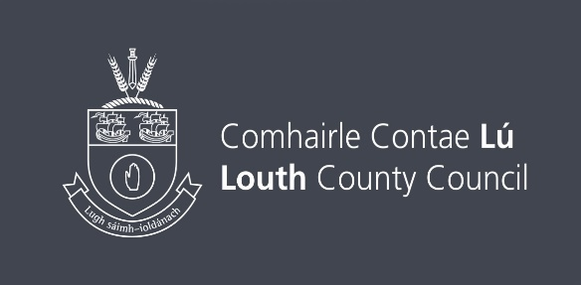

Louth EDI (Equality, Diversity & Inclusion)
Artist Practice Bursary Award 2024 Guidelines
Deadline for receipt of applications is 12th October 2024 @ 4.p.m

Max Award Available - €5,000

Information for Applicants
The Louth County Council Arts Office is pleased to offer a financial support bursary of €5,000 for artists across all art forms. This opportunity is specific to individuals from underrepresented backgrounds, including those based on age, civil or family status, disability, gender, membership of the Traveller Community, race, religion, sexual orientation, and socioeconomic status.

The bursary aligns with The Arts Council’s Equality, Diversity, and Inclusion Implementation Plan, recognising the challenges faced by such artists who are striving to advance their careers and enhance their artistic practice. By providing an element of financial relief, the bursary will allow the successful applicant the freedom to focus on the development of their practice and if relevant a specific project.

This Artist Practice Bursary Award (up to €5000) will offer the successful applicant the opportunity to focus on the development of their professional practice, develop a specific artistic project, or both. The purpose of this award is to highlight the value and benefits of engaging with one’s artistic practice and to provide an artist from an underrepresented background with the resources needed to support this process.

This award is intended to support professional artists under the following categories;
- Development of professional practice (e.g. mentorship, networking or master classes)
- Creation of new work. (e.g. materials assistance, exploration/research assistance/to allow time to concentrate on artistic practice and reflection)
- Develop a specific artistic project (e.g. collaborative work, engagement project)

Eligibility
- Artist must be from an underrepresented background (see here for further information on The Arts Councils EDI Implementation Plan)
- A professional artist for at least 3 years
- An artist residing in Louth for a minimum of 2years
- Applicants cannot be an undergraduate student at the time this bursary is offered
- Applicants must be over the age of 18 years
- Applicants cannot be in full time education
- Applications will not be accepted from groups or organisations

Applications will be assessed based on the following:

- Comprehensiveness of application form
- Tangible benefits of the bursary to the development and progression of your practice, or if relevant a specific project
- If project based, demonstration of capacity to successfully plan and execute the project
- Budget management
- Quality of supporting material (images of work, short writing samples, music samples etc. relevant research information on your proposed project)
- Artists CV

Applications will be assessed by an independent assessment panel nominated by the Louth Arts Office and all applicants will be advised of the panel’s decision by email. Applications will be assessed based on the information supplied and within a competitive context.

Supporting Documentation
- You are required to include supporting material within your application form. Online applications only are accepted (max 10 MB per application). This may include images, pamphlets, brochures, texts, sound bites, transcripts (4 pages max), video links
- Please compile all support material onto one PDF or Word Doc.
- Max of 12 still images– clearly labelled
- Video Show reel (You Tube or Vimeo) links max 6 minutes accepted- if links are password protected please ensure you have included the password to view
- A Contents List of the supporting material clearly labelled must be included in supporting application

Terms and Conditions
- The awarded funding must only be used for the specific purpose for which it has been granted.
- Where a grant is allocated for a specific award, Louth County Council will not be responsible for the insurance of that project.
- The successful applicant must satisfy Louth County Councils Health and Safety requirements.
- Funding provided by Louth County Council must be acknowledged in all publicity material.
- The successful applicant will receive a copy of Louth County Council’s logo and guidance on how to use the logo when acknowledging funding support.
- An evaluation report, and where relevant, images regarding the project must be submitted to the Arts Office on completion of work.
- Grants may be claimed in instalments by agreement with the Arts Office.
- If project based, the project should be completed within 12 months of grant award date.
- Applications must be emailed to arts@louthcoco.ie with EDI Bursary Award in the subject bar of the email.

More information:
The Arts Council’s Equality, Diversity and Inclusion Implementation Plan

Louth County Council is committed to ensuring that the national policy regarding Paying the Artist is adhered to by the Council and by those funded and supported by the Council to engage artists to work. Please refer to the Arts Council’s Paying the Artist policy when valuing your time as an artist and those collaborating with you: www.artscouncil.ie
Paying The Artist Information Weblink

Other
- Please note there is no guarantee of funding for individuals who nonetheless may have achieved the minimum criteria. The funding available is limited and eligible applications will be evaluated on a competitive basis
- Louth County Council reserves the right not to award bursaries at its discretion



