Age & Opportunity Tyrone Guthrie Centre Residency Award 2026
  - Deadline 12pm (noon), 10th June 2026
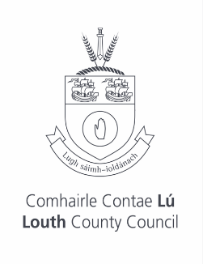
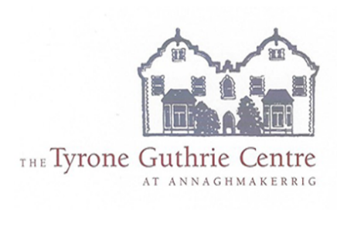
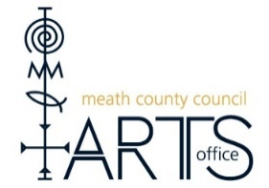



Application Form

Please read the award guidelines before completing the following application form.
The final application should be submitted to https://meathcocoarts.submit.com/ if applying from Meath and arts@louthcoco.ie if applying from Louth, no later than 12pm (noon), 10th June 2026.

Name and address of applicant (please include your Eircode):

Please indicate the county you are applying from:
Meath Louth
Phone number:
Email:
Have you ever availed of a residency in Tyrone Guthrie Centre before? If yes, please provide some detail. (100 words)
Please describe your artistic practice including your artform(s) (50 words)
How would this award contribute to your development as an artist? (100 words)
Please describe the project you would work on during the residency (max 300 words)
Please include with your application
- Short biography
- Professional artist CV
- Three samples of work e.g. images, writing samples, links to film, theatre or other art work.
(Please do not email large files but include links instead)

These last few questions allow us to gather information on the diversity and inclusivity of our programmes and we appreciate you taking the time to answer them. These questions are optional, answers will be anonymised and kept confidential.

What is your age?
50 – 60
61 – 70
71 – 85
86 or older
Prefer not to say

What is your gender?
Female
Male
Non-binary
Other (specify if you wish)
Prefer not to say

What is your ethnic or cultural background?
Asian or Asian Irish: Chinese
Asian or Asian Irish: Any other Asian background
Black or Black Irish: African
Black or Black Irish: Any other Black background
White: Irish
White: Irish Traveller
White: Any other White background
Other including mixed background (specify if you wish)

