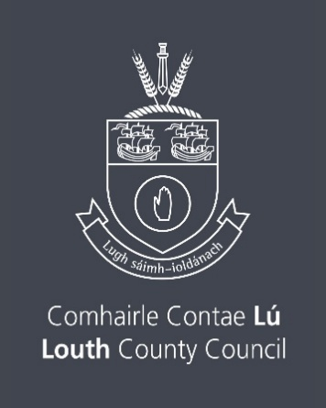

Tyrone Guthrie Centre Regional Bursary 2026
Louth County Council invites artists of all disciplines to apply for this bursary which entitles the successful applicant to a two week residency at the Tyrone Guthrie Centre in Annaghmakerrig, Co. Monaghan. The Bursary will allow the applicant to work towards the completion of a particular project in a unique working environment.
Please note there is no application form for this Bursary.
Who is eligible to apply?
Applications are invited from professional practising artists, in all art forms and genres.
Applicants must be resident in County Louth, or have their arts practice based in Louth.

To apply, the applicant must submit the following as part of the application:
(a) A full and up-to-date C.V.
(b) A signed letter applying for the Bursary, explaining how the award would benefit the work of the applicant, and any other relevant details.
The successful Applicant should on their letter of application prove conclusively that they will benefit considerably from such a residency. They will have shown evidence of a significant level of achievement in the relevant field.
The dates of the residency will be decided in consultation between the successful applicant and The Tyrone Guthrie Centre.
Louth County Council reserve the right not to award a Bursary, if it believes the interests of the County Council, the Bursary and the applicants would be best served by this course of action.
Submissions must be received by Louth County Council by 4pm Thursday 12th February 2026
Submissions should be emailed only to arts@louthcoco.ie Please put ‘Tyrone Gutherie Residency’ in the subject bar of the email submission.

Freedom of Information
Applicants making a submission to this bursary scheme should note that information provided to the Arts Office, Louth County Council may be disclosed in response to a request made under The Freedom of Information Act (1997 and 2003). Every effort will be made to protect Client confidentiality.

GDPR: The purpose for accessing your data is to process your submission for The Tyrone Guthrie Bursary. The information you provide will be used by a Panel in this submission for The Tyrone Guthrie Bursary

Please note that successful applicants will be listed on the Arts Services website www.createlouth.ie

