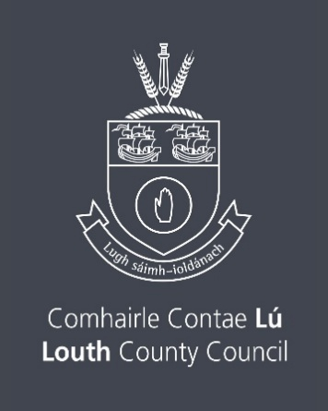

School Music Instrument Purchase Scheme 2026
Closing Date Thursday 12th February 2026 by 4.00pm
Total Available Fund € 2,000
The Arts service of Louth County Council, values and wishes to support the work of schools in the delivery of their music programme. This scheme aims to aid the development of musical instrument resources in both primary and secondary schools in the County of Louth.

Criteria & Guidelines:
(a) Schools applying must demonstrate a commitment and ability to provide music classes to pupils, if application is successful.

(b) This scheme is intended to assist with the purchase of musical instruments only, which will then remain the property of the school.

(c) It is understood that, if successful, the schools will provide Louth County Council with receipts and details of instruments purchased.

(d) This scheme is both competitive in nature insofar as the funding limit set and having regard to the fact that an assessment panel will make recommendations to LCC as to the merits of each individual submission.

(e) The Scheme is only open to primary and secondary schools located in the county of Louth.

Closing date is Thursday 12th February 2026 by 4.00pm

Name of School:
Postal Address:
Principal:
Web address (if applicable): www.
Primary Contact for this application:
Contact No: Email:
Name of Music Teacher (if different from primary contact):
Music qualifications and/or practical experience:

Please confirm that you have read the Criteria for this scheme ____________
State whether you are applying as Primary School or Secondary School ___________
Give a short description of your school to assist the panel in assessing your application including the number of pupils

Does the school own any instruments at present or have any music programmes running at present and if so please outline below

Outline the proposed instruments to be purchased including indicative costs

Outline any plans the school has for using these new instruments and how it will impact on the ambitions of the school in relation to music

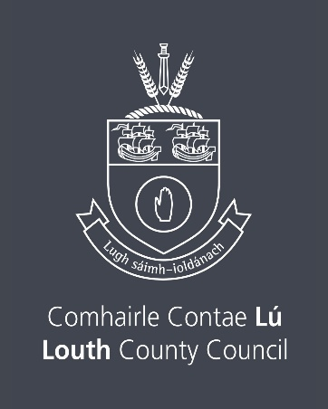
Declaration
I have read the award conditions/criteria, agree to be bound by them, and certify that the information to this Application is correct to the best of my knowledge.

Signed: __________________________________ Date: __________________

This Application Form should be returned
by email only to arts@louthcoco.ie
Please quote ‘SMIPS’ in the subject bar of the email.
Closing date for the receipt of completed Applications is
Thursday 12th February 2026 by 4.00pm
Late applications will not be considered.

Freedom of Information
Applicants completing this Form should note that information provided to the Arts Office, Louth County Council may be disclosed in response to a request made under The Freedom of Information Act (1997 and 2003). Every effort will be made to protect Client confidentiality.

GDPR: The purpose for accessing your data is to process your Application for The School Music Instrument Purchase Scheme. The information you provide will be used by a Panel in this application for The School Music Instrument Purchase Scheme only.

Please note that successful applicants will be listed on the Arts Services website www.createlouth.ie

