Louth County Council & Creative Ireland
Cruinniú na nÓg 2026 – Expression of Interest Briefing Document

Introduction
Louth County Council, in partnership with Creative Ireland, invites applications for Cruinniú na nÓg 2026. This call supports free, high-quality creative activities for children and young people aged 0–18 across County Louth on Saturday, 6 June 2026. Projects may take place in the weeks leading up to Cruinniú na nÓg, culminating in a showcase, exhibition, performance, or online release on June 6th.
Cruinniú na nÓg is Ireland’s national day of free creativity for children and young people, encouraging participation, imagination and creative expression through accessible, child-centred opportunities.
Cruinniú na nÓg in County Louth – Previous Years
County Louth has delivered Cruinniú na nÓg since its inception, with activities including outdoor creative play villages, visual arts workshops, youth theatre and dance showcases, music creation labs, heritage trails, storytelling sessions, sensory-friendly workshops, and pop-up events in libraries, community centres and public spaces. These events have engaged thousands of children and families across the county.
Alignment with Louth’s Culture & Creativity Strategy
All proposals must demonstrate how the project aligns with Louth's Culture and Creativity Strategy 2023-2027, including:
- Access for all children regardless of background or ability
- Inclusion of rural, marginalised or under-represented communities
- Support for local artists and cultural practitioners
- Youth voice, co-creation and participation
- Celebrating Louth’s unique cultural identity, creative learning and wellbeing
Consultation Process
As consultation is a requirement of the national programme, applicants are asked to outline, where possible, how children and young people informed or shaped the proposed project. This may include exploring questions such as:
- What creative activities they enjoy doing, making or attending
- What new creative experiences would they like to try
- What they would like to take part in on Cruinniú na nÓg
Applicants are encouraged to refer to Hub na nÓg the national centre of excellence for youth participation, for best-practice guidance on youth participation.
Funding Strands
Strand 1 – Up to €500: individual creative practitioners delivering small-scale activities
Strand 2 – Up to €1,500: community groups, venues and organisations delivering medium-scale projects
Strand 3 – Up to €2,500: For larger-scale creative projects delivered by venues, community groups, or organisations, offering increased reach, duration, or depth of engagement
Project Requirements
To be eligible, proposed projects must:
- Be free of charge for participants
- Be child-centred, activity-based and participatory, enabling children to do, make, create, and actively engage
- Be inclusive and accessible, reflecting the diversity of County Louth
- Include a significant element on 6 June 2026
- Outline, where possible, how children and/or young people were consulted or involved in shaping the project or programme.
- Align with the Creative Ireland Programme and Louth’s Culture & Creativity Strategy
Applicants may propose in-person, outdoor, online, or blended activities, provided they are safe, well-planned, and appropriate for the target age group.
Assessment Criteria
Applications will be assessed according to the following weighted criteria:
- Quality of creative idea & child engagement — 30%
- Alignment with Louth Culture & Creativity Strategy — 20%
- Accessibility & inclusion — 15%
- Feasibility & project planning — 15%
- Value for money — 10%
- Experience of applicant/team — 10%
Assessment and Shortlisting
- Submissions will be reviewed by Louth County Council’s Culture & Creativity Team. Applicants will be notified of the panel’s decisions by email.
- Funded applicants must acknowledge Louth County Council and Creative Ireland in all promotional materials.
- Projects involving children or young people must comply with national Child Protection policies and be supported by appropriate governance.
- Applicants must confirm that insurance (including Public Liability, where required) and relevant Health & Safety procedures are in place.
Reporting Requirements
Funded applicants must submit:
- Part A Listing Report: event details (due within 10 days of funding notification)
- Part B Post-Event Report: participation figures, feedback, and documentation (due 14 June 2026)
Failure to submit required reports may result in withholding of funds.
Terms & Conditions
- Louth County Council & Creative Ireland shall not be liable for any loss, damage or costs of any nature arising directly or indirectly from participation in this scheme.
- Funded organisations remain fully responsible for project delivery, safeguarding, and legal compliance.
- Applicants consent to the processing of submitted information for administrative, auditing, and reporting purposes.
- All imagery, video, audio, and documentation must comply with GDPR and include appropriate permissions.
- Events and programmes already running or held after June 6th, 2026, are not eligible for funding.
- Funding awarded in 2026 does not guarantee funding in subsequent years.
How to Apply
Expressions of Interest application forms are available via https://createlouth.ie/funding/ and must be submitted via email to creativeireland@louthcoco.ie by Monday, 23rd February 2026 at 4:00 pm.
For further information, please contact Lainey McQuaid, Creative Communities Engagement Officer, Louth County Council at lainey.mcquaid@louthcoco.ie or creativeireland@louthcoco.ie

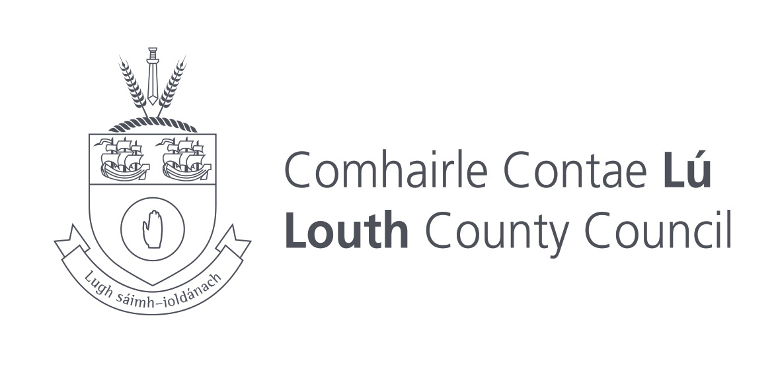 | 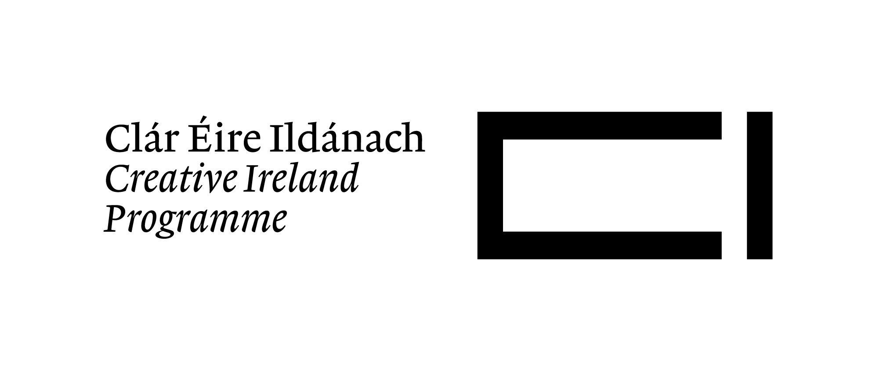 | 