Expression of Interest (EOI)

–

Cruinniú na nÓg 2026

Louth County Council & Creative Ireland

Closing Date for Expressions of Interest: Monday, February 23rd, 2026 @ 4 pm sharp
Email for Expressions of Interest & Queries: creativeireland@louthcoco.ie
Cruinniú na nÓg: June 6th, 2026

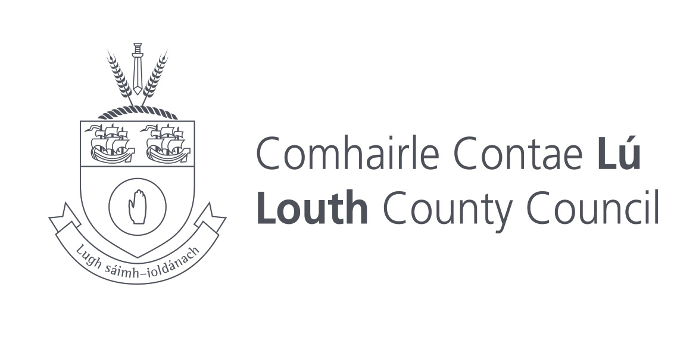 | 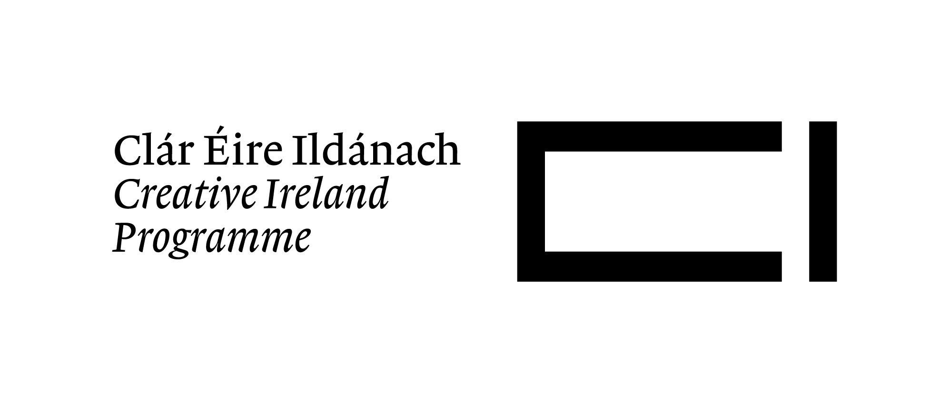 | 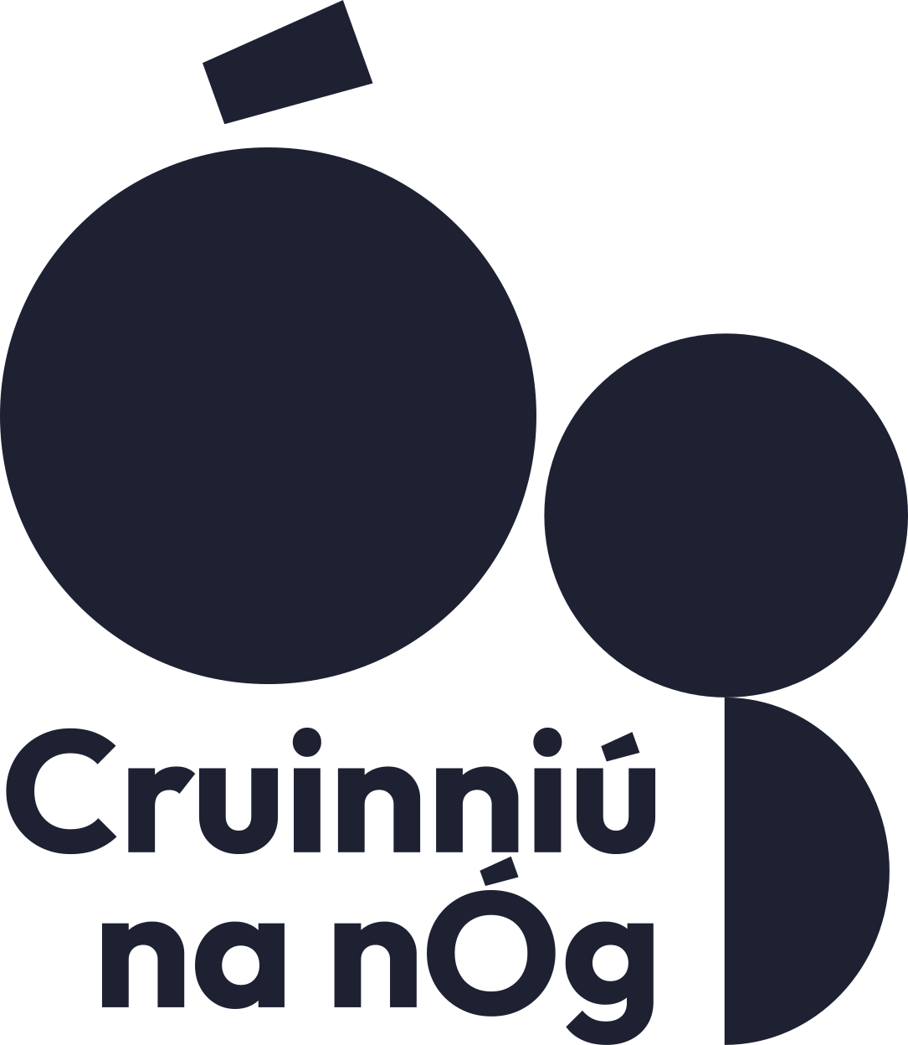
1. About Cruinniú na nÓg
Cruinniú na nÓg is Ireland’s national day of free creativity for children and young people aged 0–18. Taking place annually on the first Saturday in June, it celebrates creativity through participatory events in music, visual arts, circus, theatre, dance, storytelling, digital creativity, heritage and much more.
The initiative is delivered nationally by the Creative Ireland Programme in partnership with local authorities, cultural organisations and community groups.
Cruinniú na nÓg 2026 will take place on Saturday, 6 June 2026.
All events must be:
- Free of charge
- Child-centred and participatory
- Delivered in line with best practice in safeguarding, accessibility and inclusion
Applicants are advised to review the Expression of Interest Briefing Notes prior to submitting their applications.

2. Purpose of the Expression of Interest
Louth County Council invites expressions of interest from artists, creative practitioners, community groups, venues, and organisations to deliver high-quality, child-centred, creative activities as part of Cruinniú na nÓg 2026. The programme aims to broaden access to creativity, support local practitioners, and deliver inclusive, engaging experiences aligned with Louth's Culture and Creativity Strategy 2023-2027

3. Eligible Applicants
Eligible applicants include professional artists and creative practitioners; arts, culture and heritage organisations; community and voluntary groups; youth services and schools (non-commercial activity); creative enterprises; and venues serving County Louth.

4. Eligible & Ineligible Expenses
Eligible expenses include artist fees, materials, venue or equipment hire, accessibility supports, insurance, local travel (within County Louth), and marketing costs directly related to the event.
Ineligible expenses include core organisational running costs, capital purchases, ongoing staff wages not directly related to the project, commercial activity, retrospective funding, or events delivered after 6 June 2026.

5. Guiding Principles
Projects must:
- Be free and open to children and young people (0-18 years)
- Be participatory and inclusive of the voice of the child
- Be safe, accessible and inclusive
- Be high-quality and professionally delivered
- Encourage creativity, imagination and confidence
- Reflect the diversity of County Louth
- Demonstrate value for public funding

6. Funding Strands
Louth County Council invites applications under the following funding strands:
- Strand 1: Up to €500
- Strand 2: Up to €1,500
- Strand 3: Up to €2,500

7. Assessment Criteria
Applications will be assessed based on:
Criteria Weighting
- Quality of creative idea & child engagement 30%
- Alignment with Louth Culture & Creativity Strategy 20%
- Accessibility & inclusion 15%
- Feasibility & project planning 15%
- Value for money 10%
- Experience of applicant/team 10%
8. Terms & Conditions
- Louth County Council is not responsible for any costs incurred in preparing or delivering the project.
- Funded organisations remain fully responsible for project delivery, safeguarding, and legal compliance.
- Applicants consent to the processing of submitted information for administrative, auditing, and reporting purposes.
- All imagery, video, audio, and documentation must comply with GDPR and include appropriate permissions.
- Retrospective funding is not permitted.
- Funding awarded in 2026 does not guarantee funding in subsequent years.

Expression of Interest Application Form

Section 1 – Applicant Details

Name of Applicant / Organisation:
Contact Person:
Address:
Email:
Phone Number:
Website/Social Media:
Tax ID/Charity Number:

Section 2 – Project Overview

Project Title:
Project Type (e.g. visual arts, music, theatre, digital, heritage, etc.):
Proposed Location/Venue:
Target Age Group(s):
Number of Participants (estimated):

Section 3 – Project Description
Please provide a brief description of your proposed activity (max 200 words). For example, what will children do? How is it participatory? Why is it creative and engaging? Are there any specific accessibility & inclusion measures taken (e.g. ISL interpretation, sensory-friendly adaptations, wheelchair access)? If applicable, include details of consultations with children/young people regarding the project development.

Section 4 – Project Team
Please list all facilitators/artists involved and outline their relevant experience.

Section 5 – Audience & Outcomes
Who is your target audience, and what outcomes do you hope to achieve for participants? (Max 150 words)

Section 6 – Budget
Item Cost (€)
Artist / Facilitator Fees:
Materials:
Venue / Equipment Hire:
Accessibility Supports:
Marketing / Design:
Other (specify):
Tax ID/Charity Number:

Section 7 – Notices & Acknowledgements

The applicant(s) must agree to acknowledge Louth County Council and the Creative Ireland Programme in all promotional material.
The applicant(s) declare(s) that the information provided is accurate.
The applicant(s) understand(s) that Louth County Council and Creative Ireland shall not be liable for any loss, damage or costs of any nature arising directly or indirectly from participation in this scheme.
Louth County Council will process personal data in accordance with the General Data Protection Regulation (GDPR) and the Data Protection Acts 1988–2018. Data will be used solely for the administration of Cruinniú na nÓg and will not be shared with third parties without consent.

Signature:
Date:

