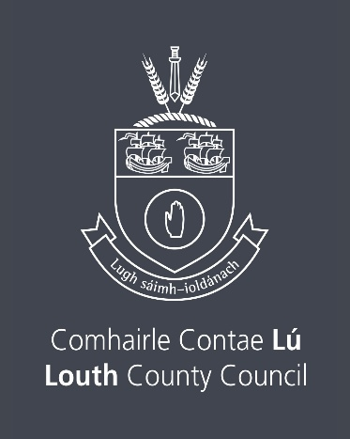

Drama League of Ireland Annual Summer School
Scholarship 2026
Closing Date Thursday 12th February 2026 by 4.00pm

The Arts service of Louth County Council, wishes to support the development and training of individuals and groups in the area of drama. The dissemination of knowledge and skills to drama groups, youth theatres, schools and other clubs and organisations can both raise standards and enhance levels of participation in this art form.

Please note there is no application form for this scholarship.

Louth County Council invites interested individuals to apply for a Scholarship which will enable a successful applicant to attend the Drama League of Ireland Annual Residential Summer School. Participants in musical theatre and pantomime societies are also welcome to apply.
The summer school will take place in mid July, dates for 2026 to be confirmed.
There will be a number of courses on offer, each taught by a professional theatre practitioner. We would ask that you reference on your letter of application which type of course you think you will be registering for.
The Residential Scholarship includes tuition, accommodation, lunch & dinner
Please note Travel costs will not be covered.
For more information see https://dli.ie/summer-school/
Please note it is the responsibility of the applicant to book their place on their course of choice themselves.

To apply, the applicant must send the following to the relevant County Council.
(a) A full up to date C.V. which makes clear the applicant’s experience in drama, or involvement in youth or community work.
(b) A signed letter applying for the Scholarship, explaining how the Scholarship would benefit the applicant or a specific group and which type of course they are planning to attend out of the 3 options outlined above.

Louth County Council reserve the right not to award a Scholarship, if it believes the interests of the County Council, the Scholarship and the applicants would be best served by this course of action.
Applicants must be 18 years or older on the 31st January, 2026

Declaration
I have read the award conditions/criteria, agree to be bound by them, and certify that the information I submit is correct to the best of my knowledge.

Signed: __________________________________ Date: __________________

This Application Form should be returned
by email only to arts@louthcoco.ie
Please quote ‘DLI Scholarship’ in the subject bar of the email.
Closing date for the receipt of completed Applications is
Thursday 12th February 2026 by 4.00pm
Late applications will not be considered.

Freedom of Information
Applicants making a submission should note that information provided to the Arts Office, Louth County Council may be disclosed in response to a request made under The Freedom of Information Act (1997 and 2003). Every effort will be made to protect Client confidentiality.
GDPR: The purpose for accessing your data is to process your submission for The Drama League of Ireland Summer School Scholarship. The information you provide will be used by a Panel in this submission for The Drama League of Ireland Summer School Scholarship only.
The successful applicant will be listed on the Arts Services website www.createlouth.ie

