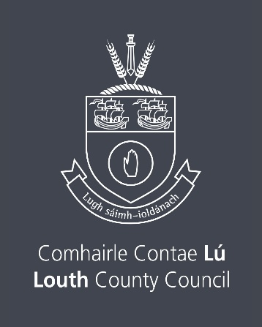

Artist Support Scheme 2026
Closing Date Thursday 12th February 2026 by 4.00pm
Total Available Fund € 5,000
Emerging Talent Established Artist
Up to 5 Awards of €400 each up to 5 Awards of €600 each
The Arts service of Louth County Council, values and wishes to support the work of the Artist and extend the range of opportunities for artists to develop their practice. We recognise that we have a responsibility to provide financial and other assistance to artists, so that they can be supported in the making and presentation of their work, and in their professional development.
- This Artist Support Scheme is open to any individual professional artist who can demonstrate their track record regardless of whether they have received funding from us in the past.
- Louth County Council would like to invite individual Artists to apply under this scheme and to have their application considered for funding by an independent assessment panel.
- We have expanded our Artistic criteria to include those of you who consider yourselves as an Emerging talent from County Louth as well those of you as Artists which have been recognised by your peers as an Established artist.
- This scheme is both competitive in nature insofar as the funding limit is set and having regard to the fact that an assessment panel will make recommendations to LCC as to the merits of each individual submission.
- Please note if you received this bursary in 2024 or 2025 you are not eligible to apply for this round in 2026.

Who is eligible to apply?
Applications are invited from professional practising artists, in all art forms and genres.
Applicants must be resident in County Louth, or have their arts practice based in Louth.

Who is not eligible to apply?
- Anyone under 18 years of age
- Undergraduate students
- Anyone in full-time education
- Anyone who received this award in the past 2 years.
Criteria and Limits Deadline – Thursday 12th February 2026
The funding Criteria and Limits will be set under 2 headings for 2026.
1: Emerging talent: where an Artist who creates work under any art form in whichever medium who is in the early stages of their career.
Our aim is to award up to 5 Awards @ €400 each under this heading. This would be recognition by LCC that you are contributing to the creative and artistic life of the County in a positive way and being rewarded as such.
2: Established Artist : where the Artist has a substantive body of work created in your career and that you have been recognised as such by your peers.
Our aim is to award up to 5 Awards @ € 600 each, which would be recognition by LCC that your career as an artist is in an established place and that your contribution to the Artistic landscape of County Louth and beyond is evident and therefore can be rewarded.
Criteria
- Artists of all disciplines and who work in any art form are welcome to apply.
- Artists must be originally from County Louth, reside in County Louth or have their arts practice/studio based in County Louth.
- Applicants in a full or part-time education programme are not eligible to apply
- The term “Emerging talent” assumes that you have presented your creative work in a discipline and through whichever medium that best suits your creative process to the public
- The term “Established Artist” assumes, that you have a substantive body of works created and that it has been presented to the public in any art form and through any medium, and that you are recognised as such by your peers.
- The Assessment of your Application will be made by a Panel using judgement, experience, and artistic endeavour.
Guidelines
- This Scheme will assist artists of all disciplines and in their area of creative enterprise, professional development, performance/exhibition of work and residency opportunities.
- Artists’ professional development, (e.g., further training, attendance at peer-to-peer workshops, travel grants within Ireland),
- Artists’ creation of art, (e.g., production costs, materials assistance, exploration and research assistance, residency assistance),
- Artists, their art and the public, (e.g., performance & recording development assistance, publication & exhibition assistance, projects carried out in collaboration with county organisations)

Closing date is Thursday 12th February 2026 by 4.00pm
Name of Applicant:
Postal Address:
Art Form/Medium which best describes your Work:
www. (online supporting address)
Contact No: Email:

Please confirm that you have read the Criteria & Guidelines section
State whether you are applying as an Emerging Talent or Established Artist ___________

Give a short description of your Arts Practice to assist the panel in assessing your application

How would this Award assist you as an Artist in your creative practice?

Are you originally from Louth ______ or reside/practice in Louth _______ Tick Status?

Supporting Documentation
To assist the panel in Assessing your Application, please include links to websites or any other sites which showcase work, where applicable. All links which reflect previous and current creative practice which best represents your work should be included.
Please note that it is not possible for us to access Dropbox or other file sharing software.
Please! Do not Post or include any physical supporting documentation whatsoever, Thank you.

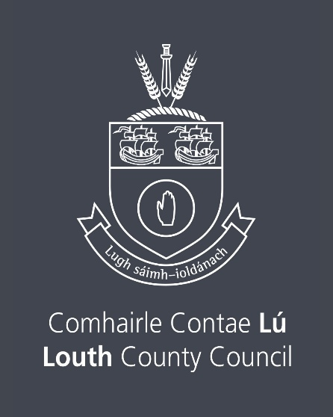

Declaration
I have read the award conditions/criteria, agree to be bound by them, and certify that the information to this Application is correct to the best of my knowledge.

Signed: __________________________________ Date: __________________

This Application Form should be returned
by email only to arts@louthcoco.ie
Please quote ‘Artist Support Scheme’ in the subject bar of the email.
Closing date for the receipt of completed Applications is
Thursday 12th February 2026 by 4.00pm
Late applications will not be considered.

Freedom of Information
Applicants completing this Form should note that information provided to the Arts Office, Louth County Council may be disclosed in response to a request made under The Freedom of Information Act (1997 and 2003). Every effort will be made to protect Client confidentiality.

GDPR: The purpose for accessing your data is to process your Application for The Artist Support Scheme. The information you provide will be used by a Panel in this application for Artist Support Scheme only.
Please note the list of successful recipients will be posted on the Arts Services website www.createlouth.ie

